MIMI PROJECT 1
SQL CODE
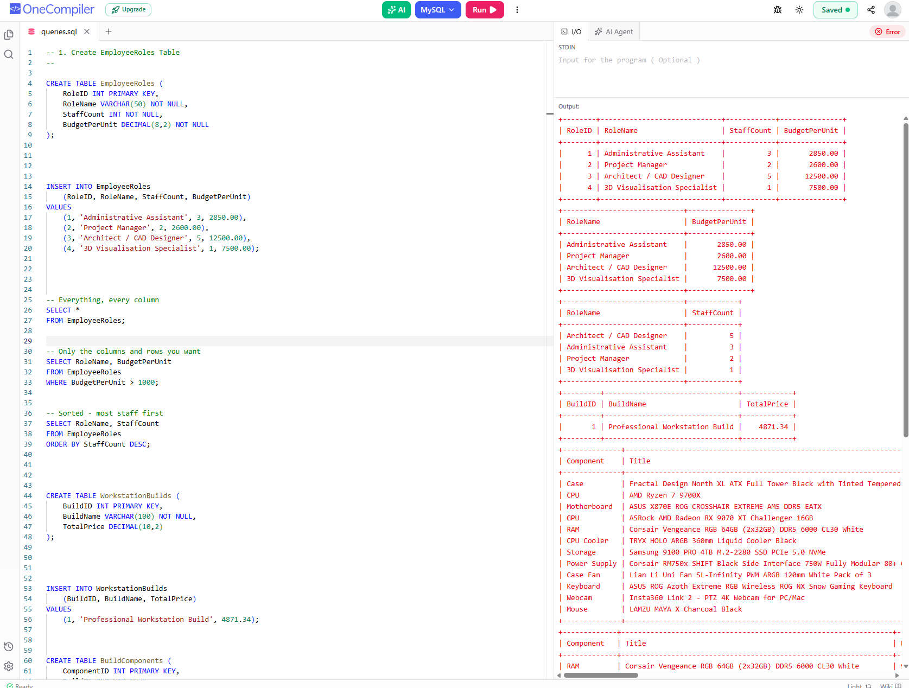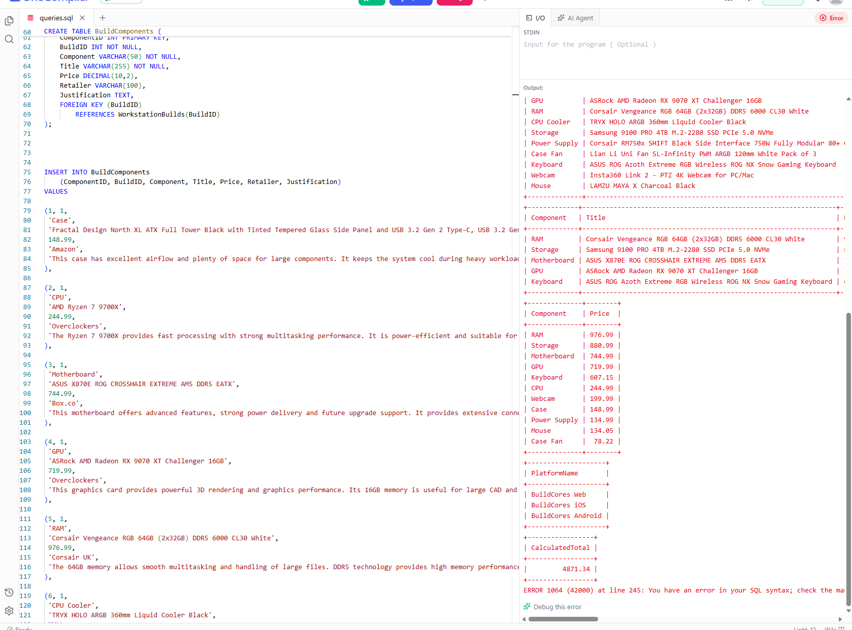
I HAVE ASLO COPIED THE LINK https://onecompiler.com/mysql/454a7etxd

